VITYARTHI PROJECT

Python Chatbot

By:
Gahira Kaur
(25BAI10026)

Dr. Antima Jain
Faculty


VIT Bhopal University
Kotrikalan – 466114
Madhya Pradesh,
INDIA.

November 2025

1. Introduction
The objective of this project is to create a Chabot in python that responds to the user’s questions. The code works on the principle of probability, calculating a percentage based on how many keywords actually match the question input by user providing much better matchibility to the correct response to the user’s questions.

2. Problem Statement
Colleges often get many questions regarding location, admissions, placements, and specific contact details from aspirants. To handle such basic questions, we can use the help of a Chabot rather than hiring someone to answer these basic questions about the institute. The problem is to automate the handling of these common queries using a robust, text-based interface to improve efficiency and provide 24/7 availability of information.

3. Functional Requirements
- Intent Recognition: The system must accurately identify what the user desires to know based on their question.
- Keyword Matching: The system must match the words in the question against a list of predefined keywords associated with each response.
- Required Word Enforcement: The feature of using required words enforces the strength of keyword matching and makes sure that the wrong response is not given to a question.
- Response Generation: Upon a successful match, the system must return a specific response.
- Handling Unknown Input: If the Chabot receives a question for which a response has not been programmed, the Chabot must have a fallback statement to provide.
- Case and Punctuation Agnostic: The system must process user input irrespective of capitalization or punctuation.

4. Non-Functional Requirements
- Performance: The response time must be very small due to the simplicity of the algorithm.
- Maintainability: The keywords and responses must be easy to update and modify.
- Reliability: The core logic must ensure a high probability of finding the correct response for known queries.

5. System Architecture
The Chabot is created in two separate files. The files are separated to simplify the code and make it easier to understand.
python_chatbot_project: Contains the main functions for input processing, probability calculation, intent checking, and the main conversational loop.
long_respnses: Stores all the predefined responses and the random fallback replies.
6. Design Diagram
Workflow Diagram
The user's input flows through the following path:
User input check_all_messages()response()message_probability()highest score selection Output

7. Design Decisions & Rationale

A. Intent Scoring (message_probability function)
Design Rationale: A simple percentage-based score is calculated to measure the match strength.
Score = (number of recognized words/total number of words in the question) x 100
This ensures that if a user uses more words relevant to the intent, the score is higher. The percentage is converted to an integer for simplicity.

B. Required Word Enforcement
Design Rationale: To ensure better keyword matching, the required_words list is created.
Since a lot of questions may use the same filler words, creating a required words list for each response ensures better matchibility of the appropriate response.

C. Input Pre-processing (get_response function)
Design Rationale: To achieve case and punctuation independence, the input is altered:
- It is converted to lowercase using .lower() function.
- It is split into a list of words using a regular expression re.split that handles spaces and common punctuation marks (,;?!.-) as delimiters. This ensures that words like "hello!" are correctly reduced to "hello".

8. Implementation Details

A. long_responses.py Structure
This secondary file consists of all the responses to the questions defined in the main file. In the main file all the keywords are assigned to separate functions that get sent to this file. The responses are stored here

B. Intent Definition
The check_all_messages function centralizes the scoring process. It uses a nested function response to simplify the definition of intents. Each intent is defined by:
- The response text.
- The list of recognized words.
- The single_response flag.
- The required_words list.
The functionchecks all the defined intents, calculates a score for each, and uses max(highest_prob_list, key=highest_prob_list.get) to select the response with the maximum score. A threshold of < 1 is used to trigger the long.unknown() response.
9.Screenshots

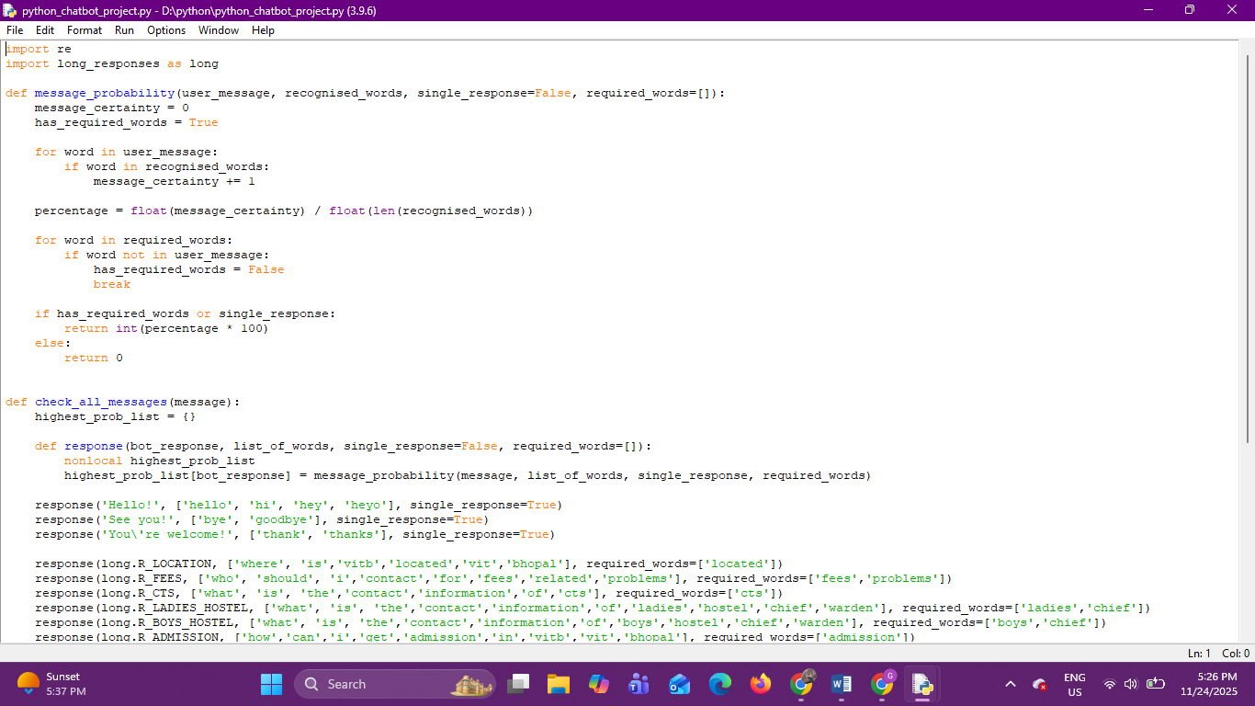
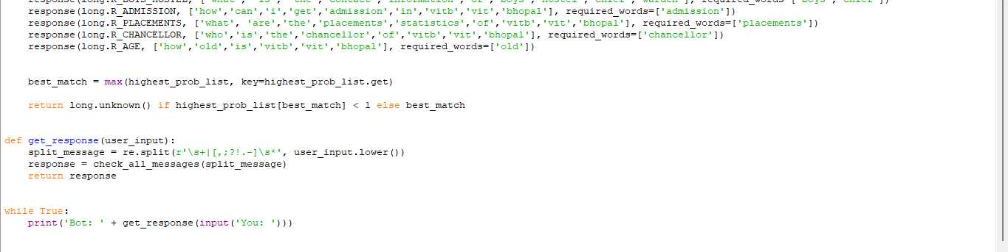
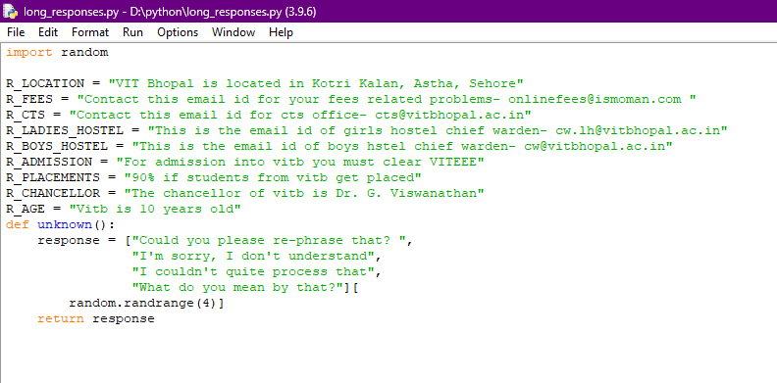

Output
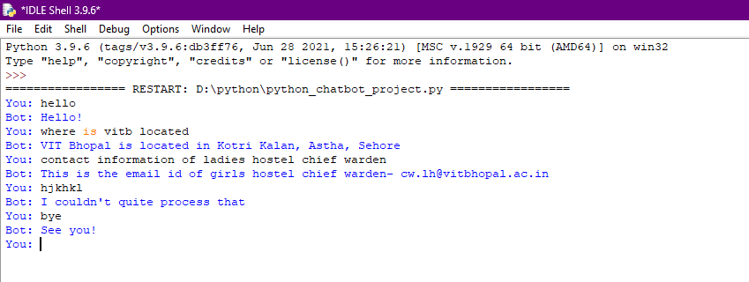

10. Testing Approach
The code was tested by simply running the code and inputing the questions coded along with some questions that were not coded to test the fallback function.
We run many iterations of the code and use different inputs to ensure that the code works properly.
11. Challenges Faced
The challenges I faced in the making of this project were:
- Coming up with a unique idea.
- Understanding the use of the python libraries that have been used in the project.
- Debugging process.
12.Learnings and key takeaways
This project helped me learn a lot about coding in Python. It helped me understand how logic flows in programming and how to design and implement a code based in real world applications.

13. Future Enhancements
While functional, the current system has limitations due to its rule-based nature. Future enhancements could include:
- Stemming/Lemmatization: Introduce a pre-processing step to reduce words to their base form to expand keyword coverage without manually listing all variants.
- Jaccard Similarity: Replace the current simple percentage score with a more mathematically robust measure like the Jaccard index to better handle long user inputs with few keywords.
- Database Integration: Migrate the static responses from a Python file (long_responses.py) to an external database to allow the content to be updated without modifying the core code.
- Context Management: Implement basic state or session tracking to handle simple follow-up questions.
14. References

1. Python

